Tasks
1.
Create a comparison table listing at least 4 key features of RADIUS and TACACS+ side by side, highlighting which protocol supports each feature.
>
Key Feature | RADIUS | TACACS+
Protocol & Transport | Uses UDP (Ports 1812/1813). It is connectionless and faster for massive public setups. | Uses TCP (Port 49). It provides connection-oriented, highly reliable transport for admin tasks.
Packet Encryption | Partial Encryption: Only encrypts the password field within the packet payload. Usernames and attributes remain plaintext. | Full Encryption: Encrypts the entire body of the packet, exposing only a minor fixed header.
AAA Architecture | Combined AA: Combines Authentication and Authorization into a single response message. | Separated AAA: Fully separates Authentication, Authorization, and Accounting into independent phases.
Command Authorization | Not Supported: Cannot control or authorize specific, individual CLI commands typed by a network admin. | Fully Supported: Allows deep control by validating every individual CLI command against an access profile.

2.
Draw a step-by-step flow diagram showing the RADIUS authentication process for a user logging in to a public WiFi hotspot, labeling each communication step between the client, network device, and RADIUS server.
>

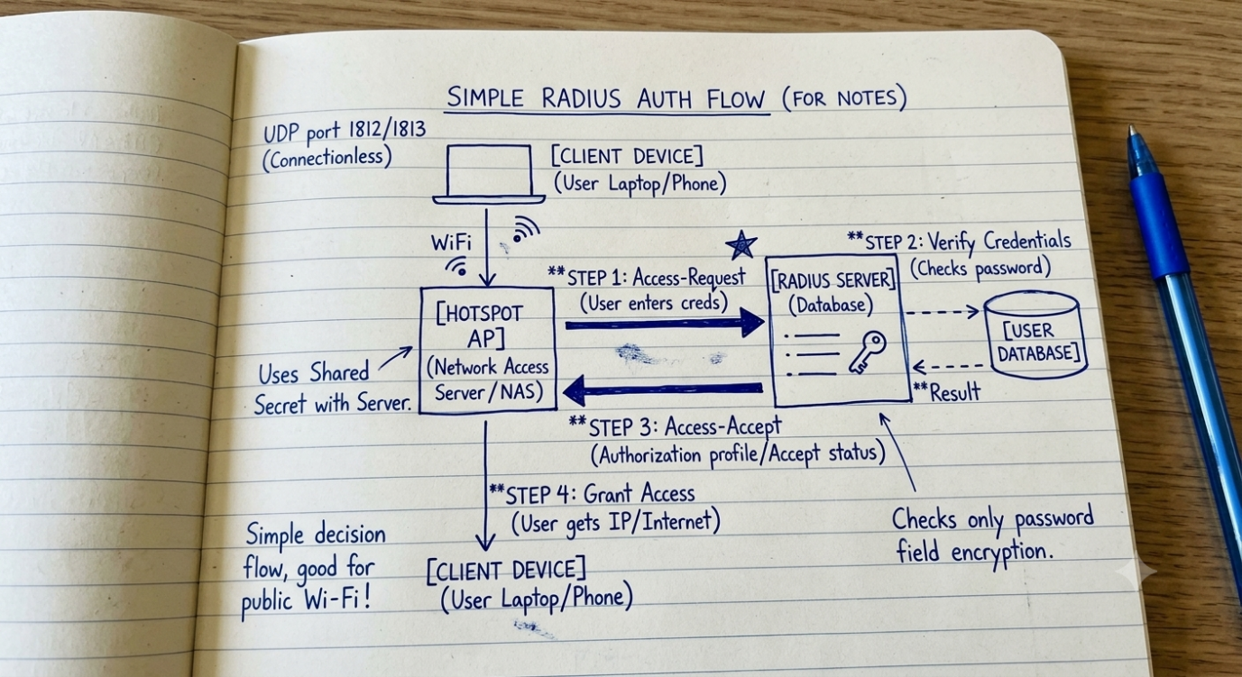

3.
List 3 real-world use cases where TACACS+ is preferred over RADIUS, and briefly explain why TACACS+ is better suited for each scenario.
>
TACACS+ is chosen over RADIUS for managing backend infrastructure access due to its high security and command-level monitoring:
- 1. Multi-Tier IT Administrator Management: In large enterprise networks, senior engineers need full access (privilege 15), while junior teams only need read-only access. TACACS+ checks every typed command against the central server profile before running it, preventing juniors from executing disruptive commands like erase startup-config.
- 2. Financial & Banking Sector Infrastructure Security: Banks require strict data isolation and auditing. Because TACACS+ completely encrypts the entire packet body (unlike RADIUS, which exposes usernames in plaintext), it prevents malicious local actors from capturing infrastructure topologies via packet sniffing.
- 3. Highly Distributed WAN Infrastructure Auditing: For large utility grids or railway systems, separate accounting logs for individual device modifications are crucial. TACACS+ provides separate accounting workflows that keep rigorous logs of exactly who modified which router interface configuration and when.

4.
Given a scenario where a user tries to log into a network device but fails authentication, describe how RADIUS and TACACS+ would handle the logging and response differently.<br><br><em><strong>Hint:</strong> Focus on how each protocol manages accounting and command authorization.</em>
>
RADIUS Protocol Handling
- Response: The RADIUS server immediately returns a single packet containing a structural Access-Reject attribute code back to the network device.
- Logging Limitations: Because Authentication and Authorization are combined, the network device log simply registers that the login attempt failed. It does not provide granular reporting details on whether the failure was due to bad password strings, account restrictions, or unauthorized privilege elevations.
TACACS+ Protocol Handling
- Response: The TACACS+ server goes through a distinct execution state loop, returning an explicit FAIL status explicitly during the separate Authentication phase.
- Detailed Auditing: Because the AAA components are isolated, the device generates rich logs. It documents exactly why the connection dropped at that specific phase, keeping the terminal session open so administrators can review accounting entries showing precisely which step failed without throwing off authorization rules.

5.
Use ChatGPT or another AI tool to generate a sample RADIUS configuration snippet for a Cisco router, then review the output and list any changes you would make to adapt it for a college campus WiFi setup.
>
Cisco Router RADIUS Configuration Snippet
! Enable AAA global configuration
aaa new-model

! Configure the RADIUS server group name and host details
aaa group server radius RAD-CAMPUS-GROUP
server-private 192.168.10.25 key CampusWiFiKey2026

! Configure default authentication for login to use RADIUS group, fall back to local database
aaa authentication login default group radius local

! Configure authorization and accounting tracking
aaa authorization exec default group radius local
aaa accounting network default start-stop group radius

Required Changes for a College Campus WiFi Setup
- Server IP Address Adjustment (192.168.10.25): Replace this placeholder IP with the actual internal IP address of the college's central authentication system (e.g., an active Windows Network Policy Server or Cisco ISE node at 10.5.1.50).
- Shared Secret Security Hardening (CampusWiFiKey2026): Change the simple placeholder key to a strong, high-entropy cryptographic password shared securely between the network switches and the RADIUS server.
- Accounting Profiles Configuration: Ensure the aaa accounting network command is fully enabled so the college can track session lengths and active data volumes consumed per student ID for internal auditing and capacity planning.

